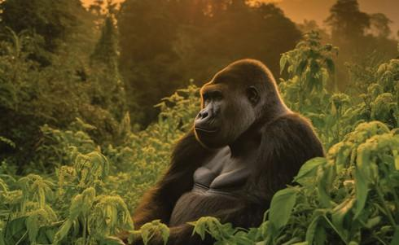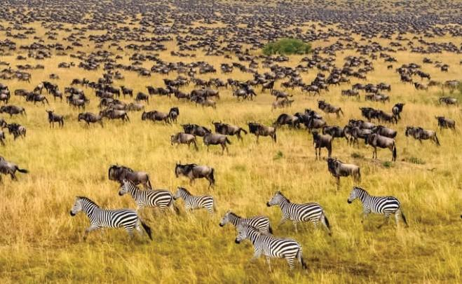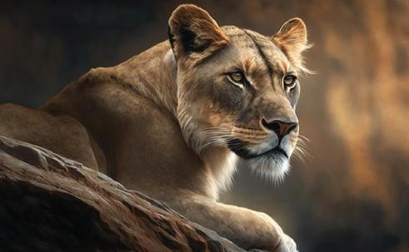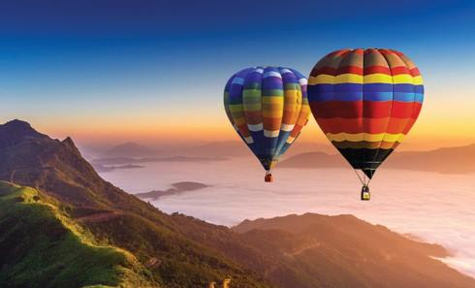

UGANDA

PRIMATES AND SAFARI EXPERIENCE IN UGANDA

Uganda is a place of extraordinary sights and unlimited adventure. The home of lofty peaks and giant fauna; of wild rivers and sweeping savannahs. It is where fantasies are set, and memories are made.

At Tilenga Safaris, we are set on a mission to organize the perfect bespoke adventures and safaris around this beautiful country we are lucky to call home.

A TASTE OF WHAT TO EXPECT
- Chimpanzee tracking
- Gorilla Tracking
- Safari Game drive to view the Big Four
- Boat cruise safari, and birding on Kazinga Channel
- Road trip
- Golden Monkey Tracking

DETAILED ITINERARY

DAY 1: ARRIVAL AND TRANSFER FROM KAMPALA TO KIBALE NATIONAL PARK

On arrival at Entebbe International Airport in Uganda, you will be met by a Tilenga Safaris guide. They will be waiting for you, holding a placard with your name, and then assist you with your luggage. Then you will make a stopover at CJs Entebbe for breakfast, and your journey to Kibale National Park begins.

Kibale National Park is the primate capital of the world, offering a large chimpanzee population with more than 120 habituated chimps and 1400 in the forest. The success rate of locating chimps while trekking is about 95%. There are opportunities for Chimpanzee trekking twice each day – the morning session starts at 7 am and the afternoon at noon, with as many as 6 groups tracking each day, each with 6 individuals.
This is a 6 to 7-hour drive from Entebbe, and chimp tracking will be scheduled the next day after your arrival.

If one is still open to adventure, an extra community walk activity in the Bigodi Swamp in the afternoon. This is a community walk through one of the most scenic areas and habitats of bird and mammal species. A 2 - 3 hour walk through the Bigodi swamp allows you to spot over 310 bird species, 5 different primates, and very beautiful flora.

Main Destination: Kibale National Park
Accommodation: 5★ Kibale Lodge | 4★ Primates Lodge Kibale | 3★ Kibale Safari Lodge
Meals and drinks: Full Board

DAY 2: CHIMPANZEE TRACKING AND TRANSFER TO QUEEN ELIZABETH NATIONAL PARK.

Early morning Chimpanzee tracking and a scenic transfer to Queen Elizabeth National Park, and relaxation at the lodge. During tracking, you will be able to see other primates and wildlife like the red-tailed monkeys, black and white colobus monkeys, and a variety of bird species, among others.
While it can be challenging to follow the lead of these agile primates, the experience is thoroughly rewarding. Queen Elizabeth National Park (the second-largest park in Uganda, named after the Late Queen Elizabeth II (RIP) and popularly known for Savannah grasslands and being home to the big cats, i.e., lions, leopards, etc., and elephants).
An afternoon – evening game drive in Queen Elizabeth National Park. QENP is home to 618 bird species, which is the 6th highest diversity in the world and the highest in Africa, making it a perfect destination for Birding, in addition to 95 mammals, including the Big 4 (Lions, Leopards, buffalo, and Hippos)

Main Destination: Queen Elizabeth National Park
Accommodation: 5★ Kyambura Gorge Lodge | 4★ Elephant Plains Lodge | 3★ Kikorongo Safari Lodge
Meals and drinks: Full Board

DAY 3: SAFARI BOAT CRUISE AND TRANSFER TO BWINDI IMPENETRABLE NATIONAL PARK

A morning boat ride on the Kazinga Channel is a highlight of the safari in Queen Elizabeth National Park, and it will reward you with wonderful sightings of Hippos, Crocodiles, Monitor Lizards, Elephants, Buffaloes, and Antelopes, and by the water, trying to stay hydrated. And then return to the Lodge for Dinner a night’s rest.
Right after the boat cruise safari, your journey to Bwindi Impenetrable National Park begins. This is a 5 – 6-hour drive from Kasese to Bwindi Impenetrable National Park. Bwindi is the habitat of more than half the world’s population of Mountain Gorillas, with over 500 mountain gorillas living here, 346 bird species, and 200 butterfly species.

The word “Bwindi” means “darkness,” and taking a hike in this magnificent forest will certainly unveil to you the reason why the forest was named so. You will also be in a position to quickly tell why the forest is also regarded as Impenetrable. One is required to be physically fit to take part in this mountain gorilla tracking / trekking adventure because it may involve climbing steep terrain.

After check-in at the lodge where you will be staying, you will have some time to swim, relax, and then have dinner.

Main Destination: Bwindi Impenetrable National Park
Accommodation: 5★ Nkuringo Bwindi Gorilla Lodge | 4★ Mahogany springs Lodge | 3★ Ride 4 A woman
Meals and drinks: Full Board

DAY 4: GORILLA TRACKING AND TRANSFER TO KISORO

Gorilla treks begin at 8 AM every day with a briefing, after which groups of a maximum of eight tourists trek into the mysterious jungle. The trek can last anywhere from 1 hour to 5 hours, depending on where the gorillas will be on a specific day.

Permits are required and limited to protect the gorillas, making the experience both exclusive and conservation-focused. Guided by trained rangers, the activity not only offers a rare and powerful wildlife encounter but also supports ongoing conservation efforts and local communities in Uganda.

And right after transfer to Kisoro from Bwindi Impenetrable National Park, to get ready for Golden Monkey tracking the day after.

Main Destination: Kisoro
Accommodation: 5★ Mt Gahinga Lodge | 4★ Lake Chahafi Safari Lodge | 3★ Lake Mulehe Safari lodge
Meals and drinks: Full Board

DAY 5: GOLDEN MONKEY TRACKING AND TRANSFER TO LAKE BUNYONYI

Golden monkey tracking in Uganda is an exciting wildlife adventure in the lush Mgahinga Gorilla National Park, where visitors trek through dense bamboo and forest habitats to observe the rare and playful golden monkeys in their natural environment, witnessing their social behaviors, vibrant golden-orange fur, and the rich biodiversity of the forest.

After Golden monkey tracking, you will be transferred to Lake Bunyonyi for a canoeing experience to the 29 forgotten Islands. Canoeing on Lake Bunyonyi to the forgotten islands is an optional activity if you’re still open to adventure.

Lake Bunyonyi in southwestern Uganda is known for its 29 islands. The phrase "29 forgotten islands” refers to the fact that many of the islands are less well-known than the most famous ones, which are notorious for their dark and fascinating pasts. The local name "Bunyonyi" means "place of many little birds," and the lake is a popular spot for birdwatching and relaxation. Canoes are the only way of getting around the lake and its islands. The locals make the canoes by digging into large trees to create a depression using axes to create a depression. The canoes are moved using rowing sticks or motor engines.

Main Destination: Kibale National Park
Accommodation:5★| 4★ Arcadia Lodge | 3★ Birdnest Resort
Meals and drinks: Full Board.

DAY 6: TRANSFER TO ENTEBBE – DEPARTURE

This is the last day in the wild. After having breakfast, you will check out and start your journey to Kampala. This is an 8-hour drive to Kampala with a stopover for lunch in Mbarara.

This is the last day of your trip; after having breakfast, you will check out and start your journey to Entebbe.

Main Destination: Entebbe International Airport
Stopover: Mbarara
Meals and drinks: Full Board.

TOUR COSTS – QUOTED IN USD
NO OF PAX | 1 | 2 | 3 | 4 | 5 | 6
COST PER PERSON – 3 STAR | 4348 | 3287 | 2893 | 2850 | 2800 | 2704
COST PER PERSON – 4 STAR | 5098 | 3696 | 3280 | 3259 | 3278 | 3114
COST PER PERSON – 5 STAR | 14.057 | 10,685 | 10,306 | 10,126 | 10,014 | 9941

What is Included
: • All Park fees
• All activities (Unless labeled as optional)
• All accommodation as per the options chosen
• A professional driver/guide
• All transportation in safari 4 X 4 vehicle with a pop-up roof
• All Taxes/VAT • Roundtrip airport transfer
• Meals (As specified in the day-by-day section)
• Complementary bottle of water per day while on safari

Package Excludes:
- International flights (From/to home)
- Visa
- Additional accommodation before and at the end of the tour
- Tips
- Personal items, Souvenirs, etc.
- Travel insurance or medical emergencies
- Government-imposed increase of taxes and/or park fees
- Drinks


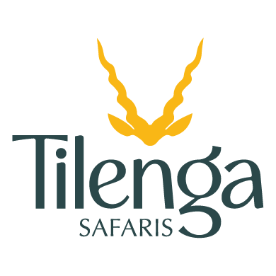
- Pottery fees

- Domestic flights
- Any Nightlife bills

